**Design Document For A Critical Game Based On In-Game Hoarding**

**Abstract**

This document will discuss how ‘critical’ games can be used to address issues in real life. It will also look at how loot and collectables play a large part in games and how they can be used to address the issues of hoarding, along with the ethics and morality of player choices. A concept for a game intended to achieve these aims will also be presented, and related to contemporary games that implement mechanics and scenarios that can be used to accomplish them.

**High Concept**

Rescue or Sacrifice. Be the Hero, be the Villain. Do what is necessary.

**Game:** Play as an adventurer in this fantasy action adventure platformer.

**Story:** The once peaceful world of the Collectimals is threatened by an Evil Demon Warlord that seeks to destroy and consume it, capturing and enslaving its inhabitants, the Collectimals.

**Environment:**

* Travel through dark and dangerous, and battle evil minions of the Demon Warlord.
* Take safe harbour in the few remaining villages, not tainted by evil.

Figure 1: Concept art of a ‘Danger Zone’ (left) and a ‘Safe Zone’ (right).

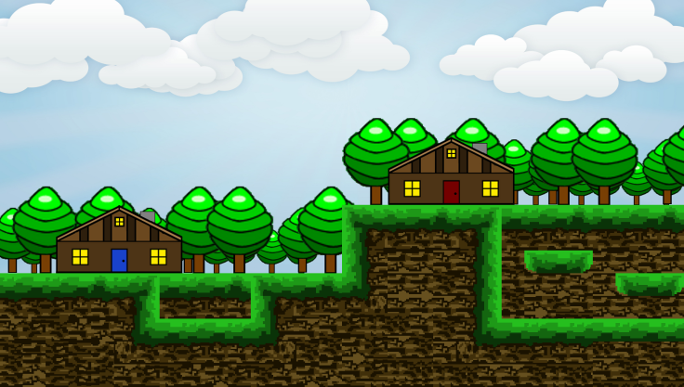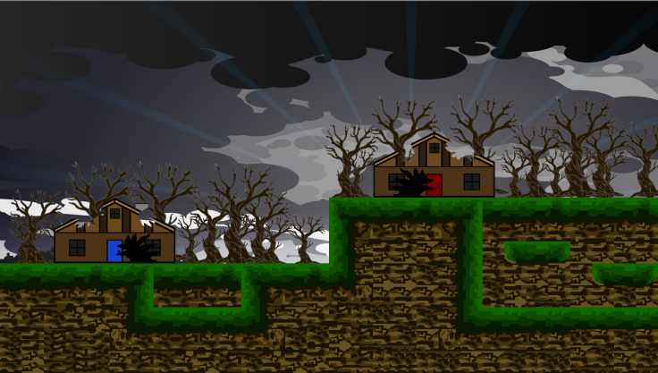

**Living items:**

* Rescue helpless creatures. Choose which to sacrifice to save the rest.
* Make moral choices; keep some to help yourself or save them all. YOU CHOOSE!!!



Figure 2: Concept art for some of the Collectimals, ‘Handgun’ creature (left), ‘gold coin’ creature (middle) and ‘shotgun shell twins’ creature (right).

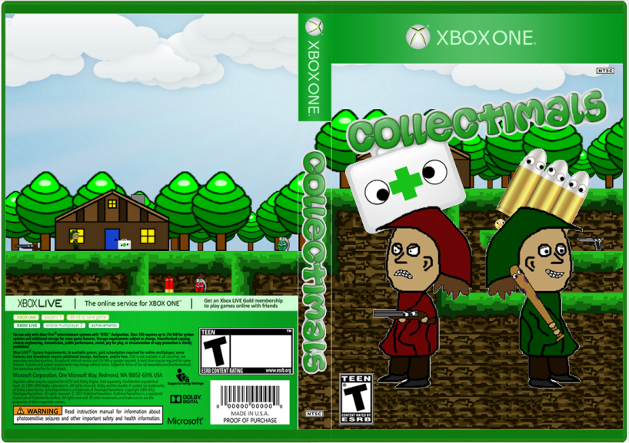

**Rescue or Sacrifice. Be the Hero, be the Villain. Do what is necessary.**

**Play as an adventurer in this fantasy action adventure platformer.**

**Environment:**

* **Travel through dark, dangerous and evil places.**
* **Take safe harbour in the few remaining villages, not tainted by evil.**

**Living items:**

* **Rescue helpless creatures. Choose which to sacrifice, to save the rest.**
* **Make moral choices; keep some to help yourself or save them all. YOU CHOOSE!!!**

**Background**

**Critical game design:** Critical game design refers to designing a game not necessarily for the enjoyment factor, instead for the goal of criticising and drawing attention to real world aspects that have an emotional or physical effect on people in day-to-day life. “Critical design uses speculative design proposals to challenge narrow assumptions, preconceptions and givens about the role products play in everyday life” (Erlhoff, 2007). This design practice is described by Grace (2010) as focusing on identifying common gameplay characteristics and highlighting the values associated with the gameplay. The outcome of which, is intended to aid in raising awareness of critical design assumptions in average gameplay.

In the article by Gualeni (2013), critical game design is described as “self-reflexive”, where the designers do not regard the gameplay experience that players have to be the ultimate goal. Instead they use it to convey certain messages or raise awareness about a certain topic. Specifically with regards to self-reflexive games, “their often uncouth gameplay serves the goal of bringing into question and demystifying aspects of the way in which we currently understand and design video games.” (*ibid*). Referring to critical game design as ‘self-reflexive’ seems to be very apt, because self-reflexive means to refer to oneself, and many critical games do refer to themselves as games and as what they are trying to address. For example in the game Spec Ops: The Line (Yager Development, 2012), it refers to itself (and other games) as being violent and possibly causing people to be violent. One instance where this can be seen is just after killing a wave of enemies, one of the enemy characters says to the player’s character “Aw jeez… Where’s all this violence comin’ from, man? Is it the video games? I bet it’s the video games.”

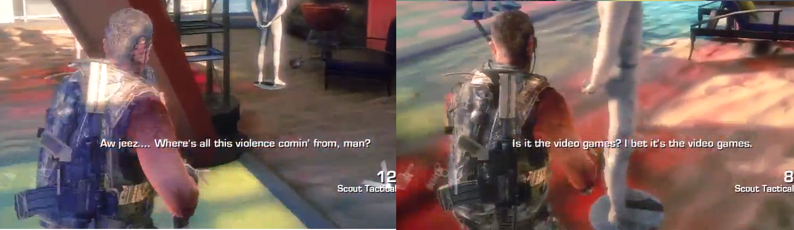

Figure 3: Screenshots showing subtitles of an enemy character’s dialogue.

Where some critical games like Spec Ops: The Line, draw attention to the fact that they are video games, others attempt to disguise themselves in unconventional experiences; this is where ‘pervasive’ games come into play. As described by Montola (2005) pervasive games refer to a genre of gaming that attempts to systematically blur and breakdown the boundaries of traditional games, and critique what people perceive as a game. This relates to ubiquitous games (Liu *et al*, 2010) and mixed reality games (Koleva *et al*, 2001), which focus on creating games that mix and intertwine games in both the real and virtual worlds. For example in the research paper by Crabtree *et al* (2004), they staged a mixed reality game in which “…online players are chased through a virtual city, by runners in the real world…” The paper explains how this sort of game helps improve communication and cooperation, by requiring the players in the control room to accurately inform the ‘runners’ where the virtual players are, and guide them in their pursuit.

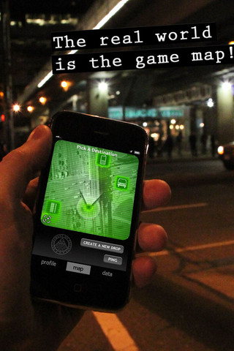

Figure 4: Photo of a Pervasive/Mixed Reality mobile game.

These types of games help to critique games in general, showing that it is difficult to narrow down the definition of a ‘game’. That games can be used to address many issues that occur in day to day life, and help to rectify or improve them. They also help to remove the assumptions that games have no benefit to the real world, that all gamers are “couch potatoes”, and show that they do indeed have benefits and can be used to better society (Fujiki, 2007).

**Ethics and Morality**

Ethics and morality, as described by Aristotle (1998), relates to a practical science that is directed at humans attempting to achieve a better life, both for themselves and others around them. In order to achieve this, humans use their own judgement when faced with various situations; thus making choices with the intention of being a good person and “doing the right thing”.

The difference between the studies of ethics and morality, as described by Pajaziti *et al* (2008) and Halis *et al* (2007), is that ethics is the study of the moral issues that exist in today’s society. That morality is determining whether a partical choice or action was good or bad, and attempt to guide a person’s actions. Ethics explores from a philisophical stand point and examines a persons actions without restricting it to a “good” and “bad, or “right” and “wrong” label, more understanding why the choice was made.

The Bioshock series (Irrational Games, 2007) showcases ethics and morality very well with the mechanic of choosing whether to ‘rescue’ or ‘harvest’ the ‘little sisters’, which are essentially infected children as shown in figure 5 below. If the player chooses to harvest a little sister then they get the full amount of ADAM (currency used to buy upgrades), but it means the little sister dies in the process. This is conveyed as a ‘bad’ thing to do, due to the reactions of other characters in the game. However if the player rescues the little sister then they get a smaller amount of ‘ADAM’, but they also get the benefit of knowing that they did the right thing. This is again conveyed to the player via how the other characters treat the player’s character. What the player chooses to do in this matter is a large factor as to what ending they will get in Bioshock 2 (Irrational Games, 2010). In Bioshock 2 the player plays as a ‘Big Daddy’ who is trying to get back his daughter. The actions that the player takes throughout the game, as to whether they rescued or harvested the little sisters, will influence his daughter to be either ‘good’ or ‘bad’ and determine the ending. This presents responsibilities to the player, in that their actions affect other people and they have consequences, just as it is in real life.

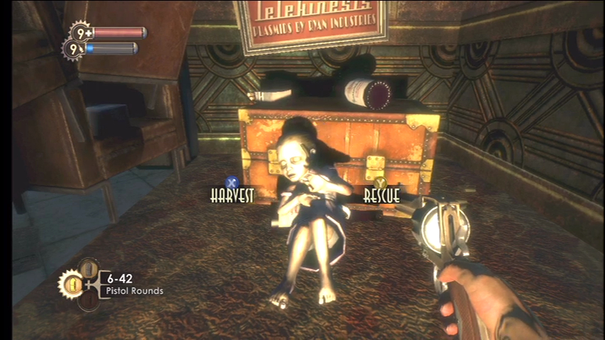

Figure 5: Screenshot from Bioshock, showing the choice to harvest or rescue a little sister.

**Hoarding**

Hoarding, as described by Frost and Gross (1993), is the “acquisition of, and failure to discard, possessions which appear to be useless or of limited value”. It is a psychological condition that has links to obsessive compulsive disorders (OCD), and in the book by Frost *et al* (1996), it has been discovered that the condition is exhibited in roughly one quarter to one third of all OCD sufferers. Compulsive hoarding also has ties with compulsive buying, since they show the same need to acquire and hold objects that may or may not have actual value. Compulsive buying has varying symptoms and affects but some common ones include: inability to control oneself, significant distress and large time consumption, along with social or financial difficulties (McElroy *et al*, 1994). With respect to games, hoarding would involve collecting every item that the player sees, but possibly never using them, even though the situation may warrant it. For example the player could be collecting and holding lots of rockets, grenades or other heavy ammo; with the intention of using them in the next boss battle. In many cases however, when the player reaches a boss encounter they think, “the next one will be tougher, I’ll save that ammo for him”.

Both conditions can cause greater psychological problems, as well as cause or worsen existing physical ones. In the article by Health and Human Services (2013), physical problems are said to include: falls and accidents due to amount of clutter, and inability for emergency personnel to enter dwelling and remove injured person. Growth of mould or rodent/insect infestations along with lack of sanitation can cause respiratory problems and infections. High levels of ammonia produced by excrements can easily exceed maximum occupational exposure limits, and can be extremely “…harmful to persons with cardiac or respiratory dysfunctions”. This shows that addressing these conditions is important, and the medium of video games will tackle the issues in an alternate manner and hopefully help diminish and/or rectify the conditions.

**Loot and game collectables**

These are objects that exist in a virtual environment that players can collect in order to achieve certain goals. They are primarily used as gameplay devices and as ways to elicit certain action from the player, or to give them the tools required to progress in the game. There are many types of collectables, but the most common ones are: money, health items and health points, weapons and ammunition, ‘key’ items for unlocking doors, experience points, upgrades and hidden collectables. Most games have their own take on each of these, for example:

* Money:
  + Gold coins in Fable (Lionhead Studios, 2004).
  + Dollars in Borderlands (Gearbox Software, 2009).
  + Red orbs in Devil May Cry (Capcom, 2001).
  + Bottle caps in Fallout 3 (Bethesda Game Studios, 2008).
* Health items:
  + First aid kits in Bioshock (Irrational Games, 2007).
  + Health potions in the Zelda series.
  + Green orbs in God of War (SCE, 2004).

Hidden collectables present the greatest variety in games, because they usually have relevance to the universe that the game is set in. For example:

* Forerunner terminals in Halo 3 (Bungie, 2007).
* Action figures in Resident Evil 5 (Capcom, 2009).
* Memories in Lost: Via Domus (Ubisoft Montreal, 2008).
* Stunt jumps in Grand Theft Auto 5 (Rockstar North, 2013).

There are instances where collecting in-game items can even turn into paid jobs, by selling virtual items to other players for real money. There is a lot of controversy surrounding this, in whether players have the right to sell in-game items and whether it is fair on other players that cannot afford to simple buy good items and consequentially being at a disadvantage to people who can (Garlick, 2005). In the newspaper article titled “Living a Virtual Life” (Levy, 2006) it is described that, although Blizzard is opposed to it (BBC, 2013), there is a thriving industry that makes vast sums of real money in the ‘Auction House’ in Diablo 3 (Blizzard Entertainment, 2012), through ‘farming’ for gold or special items and ‘power levelling’. Farming refers to playing a game for countless hours with the intention or acquiring unique items whilst raising vast sums of in-game currency. In many cases by repeatedly entering a room, collecting all the items, then exiting and re-entering the same place over and over because it is the fastest way to get good items. The player then sells the gold and items in the ‘auction house’ or ‘black market’ for real money. Power levelling is similar to farming but alternatively the player uses someone else’s character to play for numerous hours, levelling it up and collecting items for them, getting paid in the process. One example that was mentioned in the article was of a 24 year old (at the time of publication) living in China who spends 8 hours a day collecting game loot, selling it on the black market and receiving around $30 for his efforts.

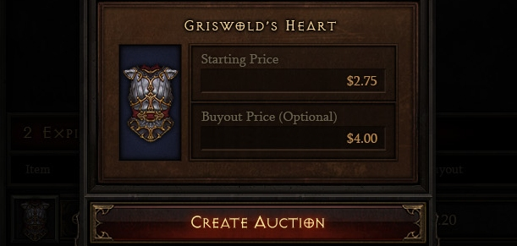

Figure 6: Screenshot of an item in the ‘Auction House’ from Diablo 3 (2012), (PCgamer, 2011a).

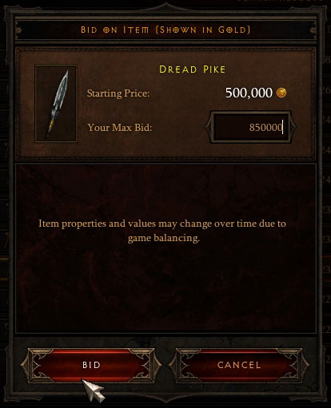

Figure 7: Screenshot of another item in the ‘Auction House’, (CTrust Network, 2012).

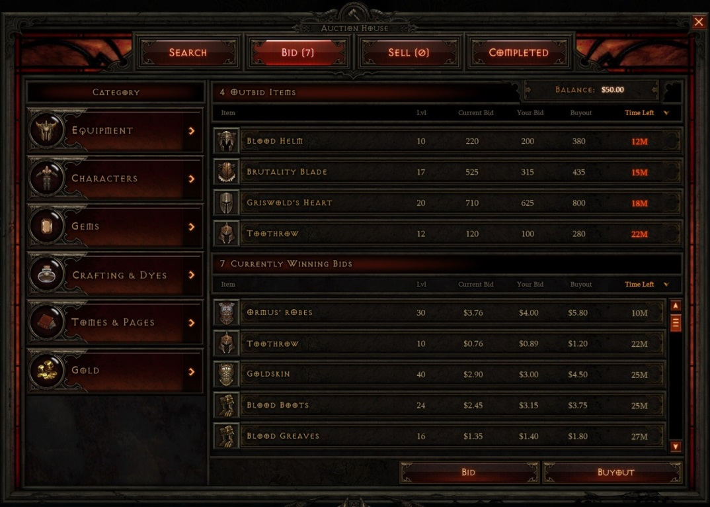

Figure 8: Image of ‘Auction House’ from Diablo 3, (PCGamer, 2011b).

**Losing items**

Many games implement scenarios that force the player to lose their items; these are usually scripted and take the form of being captured, entering a stealth section or simply reaching the end of a mission. These are most likely used due to the designers wanting to either make the game more realistic i.e. breakable items or starting a mission with a different load out, or it could be due to an element in the game’s story that warrants it i.e. a capture scene or stealth section. In both cases the game is being prolonged by essentially pulling the player back, but disguising it as general progression in the game, it’s especially apparent in the capture scenario.

**The ‘capture’ scenario:** One of the more common scenarios is the ‘capture’ scenario. This is where the player is captured by enemies in the game and is locked up, losing all the items that they have collected up until that point. Sometimes it is possible to regain these lost items by collecting them from some kind of storage or by defeating the enemy who took them. Some games that feature this scenario are:

* Deus Ex (Ion Storm, 2000).
* Quake 4 (id, 2005).
* Silent Hill: Homecoming (Double Helix, 2008).
* Half Life 2 (Valve, 2004).
* Skyrim (Bethesda, 2011).

**Losing items at the end of the mission:** This is the most common scenario and happens when the player completes a mission in a game. In these situations players are unable to carry over the weapons and equipment that they have collected in the previous mission. In many cases this is due to the context of the following mission, the player may play as a different character or be in a different part of the world with different weapons. It may also be due to the type of mission e.g. a beach assault, to a bunker breach, followed by an assassination mission. Some game series with examples of this are:

* Battlefield.
* Call of Duty.
* Halo.

This also happens in most RTS games, where the player must build a base, collect resources and raise an army for each mission. For example:

* Age of Empires.
* Star Trek: Armada.
* Command and Conquer

**The ‘stealth section’ scenario:** These sections relate to any situation where the player has their items removed because the game requires them to play in a certain way for the next mission or part of a level. This is most common in stealth and infiltration missions, where the player loses everything except their suppressed weapons and stealth equipment, or all but the most concealable items if they are required to infiltrate a party by posing as a quest for example. Some examples can be found in the games:

* Red Faction (Volition, 2001).
* Tomb Raider (Crystal Dynamics, 2013).
* No One Lives Forever (Monolith Productions, 2000).

**Breakable items:** Some games implement degradable items that breakdown over time and usage. This increases the amount of item management that is required in the game since players have to take constant care of their items if they want to continue using them; this can involve going to a blacksmith/repair shop often to get them repaired. Some game with examples of this are:

* Drakan: The Ancients’ Gates (Surreal Software, 2002).
* Silent Hill: Downpour (Vatra Games, 2012).
* The Elder Scrolls: Oblivion (Bethesda Game Studios, 2006)

**Summary**

Loot and game collectables, as well as the obsessive compulsive collecting and hoarding of the items, appears to be a rich area in which to base a critical game. The aim of the game would be to critique and analyse the psychological and physiological effects of these phenomena, and perhaps aid in the alleviation them. It would also critique the moral and ethical choices that players make in games, by considering the importance of good and bad choices (discussed in the ethics and morality section) and look at the benefits to the choices that they make. The game would be based around drawing attention to, and attempting to encourage people who suffer from these issues (to any degree), to make the right choices about their about material possessions, both their acquisition and retention. This would be achieved by implementing game mechanics that encourage players to let go of the items they have collected, by providing benefits for doing so. As mentioned in the sections above, collecting items is a large part of many games and there are many that contain mechanics that facilitate for items to be taken from the player, but there are few that provide a positive outlook or benefit to the player, other than simply progressing in the game. In most cases it is viewed as an annoyance by the player because it is out of their hands, but by linking a positive moral view to letting go of the items and conversely, a negative one to keeping them, the game will hopefully accomplish the goals previously stated. The players will hopefully adopt this mind set not only in the game, but also in their own lives because they will view it as the right thing to do.

**Game Design**

**Game title:** Collectimals; name based on the Xbox 360 game Kinectimals (Frontier Developments, 2010) due to both aiming for ‘cute’ living creatures.

**Game concept and story:** Collectimals is a cartoony style 2D action adventure platformer side-scroller with an emphasis on seeking out and collecting items. It is similar to games such as Super Mario Brothers (Nintendo, 1985), Sonic the Hedgehog (SEGA, 1991) and Mega Man (Capcom, 1987). The player will travel through ‘Danger Zones’, battle evil creatures and rescue friendly living items, the Collectimals. The Collectimals take the form of living items, like first aid kits, bullets, shotguns and grenades. As the player travels through the world they will reach ‘Safe Zones’, these provide momentary safety from enemies and allow the player to manage their inventory and prepare for the next ‘Danger Zone’. The zones are easily distinguishable because safe zones are lush countryside areas with peaceful villages and settlements, whereas the danger zones are areas that have been tainted and ruined by evil.

The story revolves around an adventurer whose land is threatened by an evil Demon Warlord that seeks to destroy and consume the land, and enslave its inhabitants, the ‘Collectimals’. The player takes on the role of the adventurer and can use the Collectimals to help fight off the Demon Warlord’s minions, by sacrificing bullets, shotgun shells and grenades to kill the minions, and using first aid kits to heal himself/herself, and eventually defeat the Demon Warlord.

Figure 9: Concept art of gameplay in a ‘Safe Zone’.

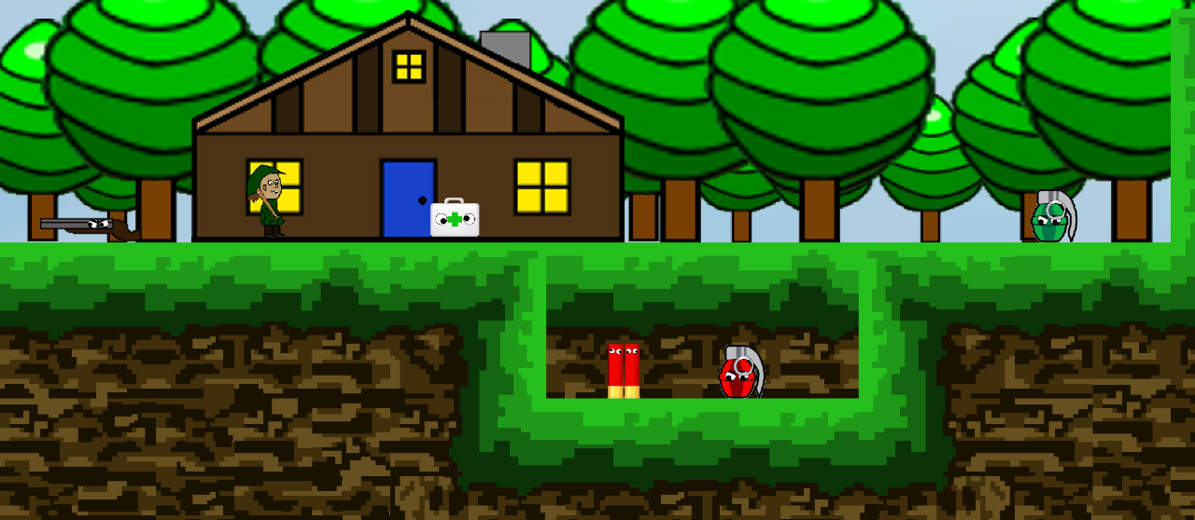

Player

Friendly NPCs.

**Living items:** As the player progresses through the game they will come across items that can be collected, but opposed to inanimate objects as in most games, they are living creatures. Using living items will hopefully help players to create a more emotional and morality driven attitude towards them and encourage players to do the right thing for them. Using living items may initially encourage players to hold on to them because they don’t want to use them and consequentially killing them, but it will also mean a very high chance that players will want to release the items when they reach safe zones (releasing items is explained later in the document).



Figure 10: First aid kit creature (left), Bullet Trio creatures (middle) and Baseball bat creature (right).

**Multiple item types:** Some items will have multiple versions of them that will allow the player to take on different play styles, along with learning to use the right item for the situation. This is a technique used in many loot based games, to easily increase the number of items, for example: Borderlands (Gearbox, 2010) or Resident Evil 4 (Capcom, 2005). An example of this in Collectimals is the three types of grenades, each one with different attributes and uses. As shown in figure 11, the three types are: the ‘Frag Grenade’, which is the standard form for the grenade and can deal large amounts of damage to multiple opponents. The ‘Incendiary Grenade’, which scatters fire over the ground for constant and prolonged damage. The final one being the ‘Flash Grenade’, which is useful for blinding enemies and allowing the player to sneak past unseen.



Figure 11: ‘Frag Grenade’ creature (left), ‘Incendiary Grenade’ creature (middle) and ‘Flash Grenade’ creature (right).

This will add another aspect to how players interact with the items, because they may have a preference to which grenade they use, so they keep that type and free the others. Alternatively the player may want to keep a couple of all three types, so they are prepared for all situations. It will hopefully help the player to decide what they really need to keep and whether all three types are necessary. This links in with real life hoarding, does the hoarder really need all those items or can they let some go.

**Inventory:** As players collect items they can store them in their backpack, which serves as the inventory. It takes the form of a standard slot inventory system, where all items irrespective of their sizes fit into one slot. Where multiple items of the same type can be stacked on top of each other (figure 12). This type of inventory system will provide easy management for players and allow them to clearly see what items they have, along with choosing which ones to use or release. Some games that use this system are: Darksiders 2 (Vigil Games, 2012), Resident Evil 5 (Capcom, 2009) and Silent Hill 2 (Konami, 2001).

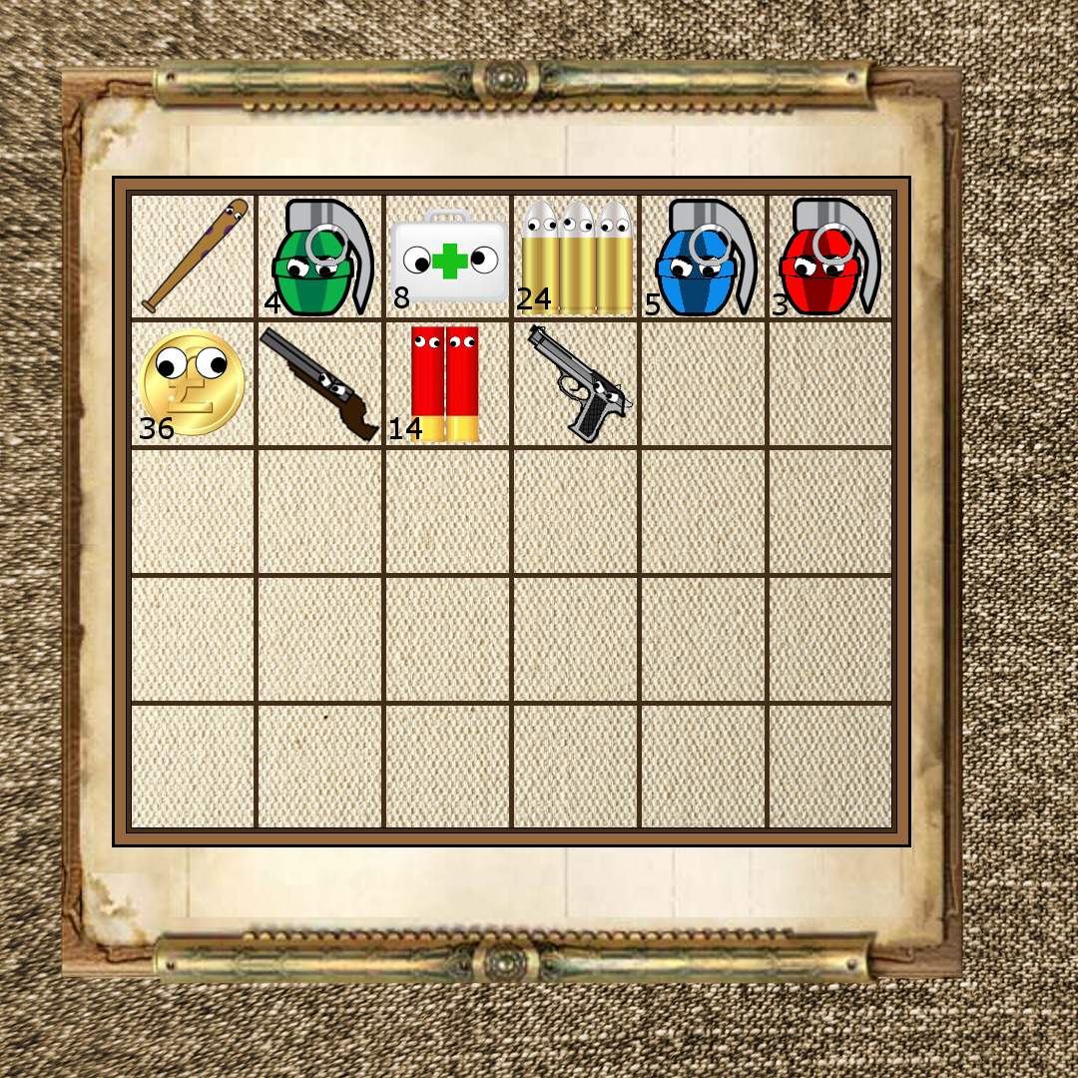

Figure 12: Concept art for the player’s inventory system.

**Enemies:** The enemies that the player will be facing are the minions of the main baddy, the Evil Demon Warlord (concepts for both are shown in figure 13). The minions will have similar abilities to the player’s character and will attack him on sight. In each new Danger Zone the minions will get tougher by having more armour, stronger weapons or by using large creatures to attack the player. This will help to encourage the player to carefully manage their inventory before each Danger Zone. The Demon Warlord will act as the final boss that the player will have to overcome, in order to save the world and free all the Collectimals. It would take a form similar to a dragon or the Balrog from The Lord of the Rings (Jackson, 2001), and would be a formidable foe. When the player faces him, all of the Collectimals that the player has saved during the game will come to help him/her in fighting the Demon Warlord. This is similar to the ending of Bioshock 2, where all the little sisters that the player has saved, come to help him/her escape Rapture (underwater city where the game is set). This will reward the player for doing the right thing throughout the game by rescuing the Collectimals, again reinforcing the idea that it is good to let go of possessions in real life.

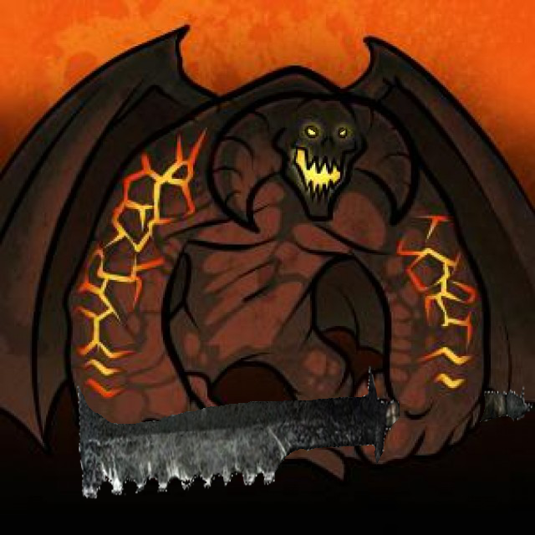

Figure 13: Concept art for a standard melee Minion (left) and the Evil Demon Warlord (DragoArt, 2012) with a large sword (Amazon, 2010) (right).

**Danger zones:** These areas are where the player battles enemies and collects items, and provide for the bulk of the gameplay. They were once lush and safe environments, but have been taken over by evil and show remnants of villages and settlements. In these areas the player comes across items that have been captured and placed in cages, or are hiding from the enemies. In these cases the player can collect the items and choose to taken them to safety or use them along the way. This also brings into play the idea of “the needs of the many outweigh the needs of the few”; by using some of the items, the player has a greater chance of getting the others to safety.

The design of these areas would consist of a dark colour palette; such as greys, blacks and browns. The overall feel that would hopefully be conveyed to the player would be that these are dangerous places that have been destroyed by evil (figure 14).

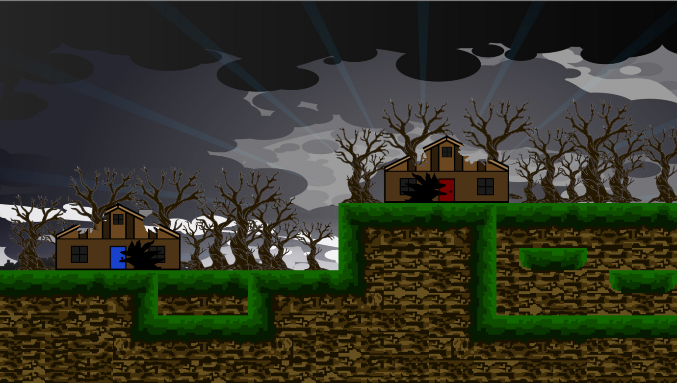

Figure 14: Concept art for a section of a ‘Danger Zone’ in Collectimals.

**Safe zones:** These zonescontrast to the danger zones and provide a safe haven for the player. It is also where many Collectimals go to live, when their homes are destroyed. The design of these areas will contrast that of the danger zones and will use a more vibrant colour palette consisting of: whites, yellows, blues, reds and greens (figure 15 below). This will help to show the player that these are good areas in which to live, and will encourage players to set their items free here.

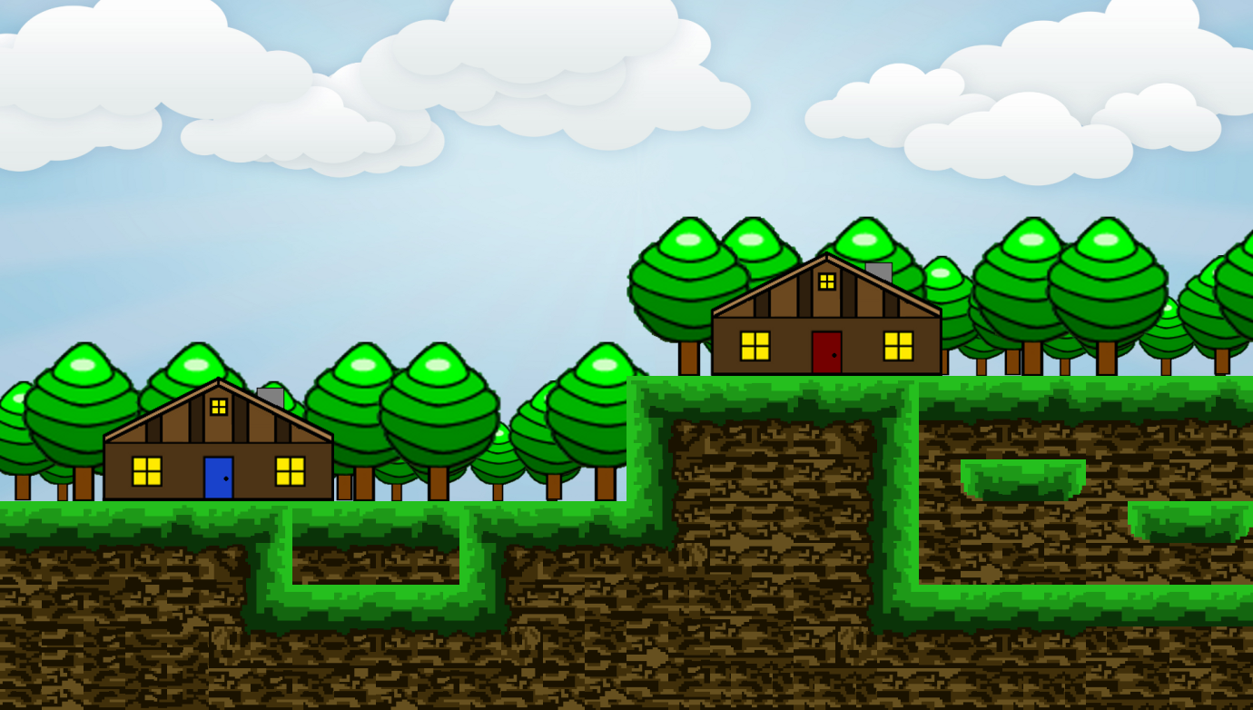

Figure 15: Concept art for a ‘Safe Zone’ in Collectimals.

**Releasing and hoarding:** When the player rescues item creatures and reaches a safe zone, the player can choose to release some of the items he/she has collected, so they can stay safe in the safe zone. This provides a morality choice of “doing what’s right” at the expense of losing valuable resources. This draws contrast to people hoarding in real life, by letting go of objects they may lose some useful items, but they are doing the right thing by taking steps to improve their physical and psychological health.

**Player Morality:**

As mentioned in the previous sections, the player can choose to either ‘release’ or ‘sacrifice’ the Collectimals that he/she collects. This is a similar to the choices in the Bioshock games, where the player is given the choice to either ‘rescue’ or ‘harvest’ little sisters (explained in the background). By taking the ‘good path’, occasionally throughout the Bioshock games the rescued little sisters will reward the player with an item package. This is the reward for doing the right thing in Bioshock and is similar to the reward in Collectimals. In that doing the right thing in the game will hopefully encourage people in real life to let go of their possessions and as consequent improve their physical and mental health. The idea of moral choices is also presented in the games: Star Wars: Knights of the Old Republic (Bioware, 2003) and Mass Effect (Bioware, 2007), where the player is shown as either good or bad depending on their choices.

In Collectimals, by using the items the player can better fight against the enemy minions, allowing him to more easily progress through the game and rescue more. Although rescuing and releasing Collectimals does make the game more difficult, the player gets the benefit of knowing he/she is doing the right thing. This mirrors hoarding in real life, in that it may be difficult for a person to let go of their possessions, but they will get benefits from doing so by improving their health. This links in with the Ethics and Morality section in the background, in that players may be using the items with the idea that they can better save more because they have the resources to do so. This is both a good and bad decision, but instead of labelling it as such, as would happen in the study of morality, it is better to understand why the choice was made, as would happen in the study of ethics. There are both good and bad reasons why people hoard in real life and instead of focusing on them, it is better to focus on understanding why the person makes the choices that they do and attempt to address them. By playing this game, players with hopefully be encouraged to think about their issues in an ethical way and concentrate on rectifying them, and not getting caught up in whether their decisions are good or bad, just that they are making overall progress and are getting better.

As a visual cue, the player character’s appearance will change depending on how many Collectimals he/she sacrifices and how many he/she saves. If the player sacrifices more Collectimals, then the character’s outfit will turn red and he will have an angry face, however if the player saves more Collectimals, then the character’s outfit will turn green and he will have a happy face. Concept art for these two character types is shown in figure 16.



Figure 16: Images of the good (left) and bad (right) player characters from the game.



**Overall goal:** The overall goal of the game is to encourage players to not get so attached to material things and encourage them to find benefit out of letting go of their possessions. It will hopefully help people with obsessive collecting and hoarding disorders, to alleviate the psychological and physiological symptoms and eventually lead better lives as a result. Using living items in the game will help to encourage players to think seriously about the actions that they take and influence the desired actions of releasing their items. Using living items will draw parallels to people and animals in real life who are in need, and as shown by the numerous organisations aimed at helping people and safe guarding animals, it is a natural instinct of humans to care for those in need.

**Ludography:**

Bethesda Game Studios (2006) *The Elder Scrolls: Oblivion*. [game]. Maryland USA: Bethesda Softworks.

Bethesda Game Studios (2008) *Fallout 3*. [game]. Maryland USA: Bethesda Softworks.

Bethesda Game Studios (2011) *Skyrim*. [game]. Maryland USA: Bethesda Softworks.

BioWare (2003) *Star Wars: Knights of the Old Republic*. [game] San Francisco, USA: Lucas Arts.

BioWare (2007) *Mass Effect*. [game] Washington, USA: Microsoft Game Studios.

Blizzard Entertainment (2012) *Diablo 3*. [game] California, USA: Blizzard Entertainment.

Bungie (2007) *Halo 3*. [game]. Washington, USA: Microsoft Game Studios.

Capcom (1987) *Mega Man*. [game] Osaka, Japan: Capcom.

Capcom (2000) *Devil May Cry*. [game] Osaka, Japan: Capcom.

Capcom (2005) *Resident Evil 4*. [game]. Osaka, Japan: Capcom.

Capcom (2009) *Resident Evil 5*. [game] Osaka, Japan: Capcom.

Crystal Dynamics (2013) *Tomb Raider*. [game]. Tokyo, Japan: Square Enix.

Double Helix Games (2008) *Silent Hill: Homecoming*. [game]. Tokyo, Japan: Konami.

Frontier Developments (2010) *Kinectimals*. [game]. Washington, USA: Microsoft Game Studios.

Gearbox Software (2009) *Borderlands*. [game]. California, USA: 2K Games.

id (2005) *Quake 4*. [game]. California, USA: Activision.

Ion Storm (2000) *Deus Ex*. [game]. London, England: Eidos.

Irrational Games (2007) *Bioshock*. [game] California, USA: 2K Games.

Konami (2001) *Silent Hill 2*. [game]. Tokyo, Japan: Konami.

Lionhead Studios (2004) *Fable*. [game]. Washington, USA: Microsoft Game Studios.

Monolith Productions (2000) *No One Lives Forever*. [game]. California, USA: Fox Interactive.

Nintendo EAD (1985) *Super Mario Brothers*. [game] Tokyo, Japan: Nintendo.

Rockstar North (2013) *Grand Theft Auto 5*. [game]. New York, USA: Rockstar Games.

SCE Santa Monica Studio (2005) *God of War*. [game]. Tokyo, Japan: Sony Computer Entertainment.

Sonic Team (1991) *Sonic The Hedgehog*. [game] Tokyo, Japan: Sega.

Surreal Software (2002) *Drakan: The Ancients’ Gates*. [game]. Tokyo, Japan: Sony Computer Entertainment.

Ubisoft Montreal (2008) *Lost: Via Domus*. [game] Montreuil-sous-Bois, France: Ubisoft.

Valve Corporation (2004) *Half Life 2*. [game]. Washington, USA: Valve Corporation.

Vatra Games (2012) *Silent Hill: Downpour*. [game]. Tokyo, Japan: Konami.

Vigil Games (2012) *Darksiders 2*. [game]. California, USA: THQ.

Volition (2001) *Red Faction*. [game]. California, USA: THQ.

Yager Development (2012) *Spec Ops: The Line*. [game] California, USA: 2K Games.

**References:**

123RF. *Image of gold cartoon pound coin*. [image]. Available from: <http://us.cdn3.123rf.com/168nwm/tassel78/tassel781201/tassel78120100029/12066325-gold-coin-with-pound-sterling-sign-illustration-isolated-on-white-background.jpg>. Accessed: [Friday 29th November 2013].

7-Star-Admiral (2007) *Image of a shotgun shell*. Available from: <http://www.7-star-admiral.com/add/0080_shotgun_shell_clipart.jpg>. Accessed: [Friday 29th November 2013].

Amazon (2010) *Image of an orc sword*. [image]. Available from: <http://g-ecx.images-amazon.com/images/G/01/videogames/2011/promos/orc_sword_amazon._SL500_.png>. Accessed: [Wednesday 4th December 2013].

Aristotle (1998) *Nicomachean Ethics*. Oxford: Oxford University Press.

BBC (2013) *Diablo 3 auction houses are doomed by developer Blizzard*. [online] London: BBC. Available from: <http://www.bbc.co.uk/news/technology-24152225>. Accessed: [Friday 22nd November 2013].

Crabtree, A. *et al* (2004) Orchestrating a Mixed Reality Game ‘On the Ground’. In: Conference on Human Factors in Computing Systems, Vienna: Austria, 24-30 April, 391-398.

CTrust Network (2012) *Image of an item in the Diablo 3 auction house*. [image] Available from:<http://images.ctrustnetwork.com/static_pages/gaming/diablo_3/Auction_house/Basics/diablo.3.auction.house.bid.jpg>. Accessed: [Friday 22nd November 2013].

DragoArt (2010) *Image of a dead cartoon tree*. [image]. Available from: <http://imgs.steps.dragoart.com/how-to-draw-a-dead-tree-step-7_1_000000026627_5.jpg>. Accessed: [Sunday 1st December 2013].

DragoArt (2012) *Image of the Balrog from The Lord of the Rings*. [image] Available from: <http://imgs.steps.dragoart.com/how-to-draw-balrog-lord-of-the-rings-balrog-step-8_1_000000087175_3.jpg>. Accessed: [Wednesday 4th December 2013].

Erlhoff, M. and Marshall, T. (2007) *Design Dictionary: Perspectives on Design Terminology.* Boston: Walter de Gruyter.

Fort Frolic (2013) *Image of a little sister, rescue or save, moment from Bioshock*. [image] Available from: <http://fortfrolic.com/wp-content/uploads/2013/05/harvest-or-rescue.jpg>. Accessed: [Friday 22nd November 2013].

Frost, R. O. and Gross, R. C. (1993) The Hoarding of Possessions. *Behaviour Research and Therapy*, 31, 367-381.

Frost, R. O., Krause, M. and Steketee, G. (1996) Hoarding and Obsessive Compulsive Symptoms. *Behaviour Modification*, 20, 116-132.

Fujiki, Y. *et al*. (2007) Neat-o-Games: Ubiquitous Activity Based Gaming. *Extended Abstracts on Human Factors in Computing Systems*, 2369-2374.

Garlick, M. (2005) Player, Pirate or Conducer? A Consideration of the Rights of Online Gamers. *Yale Journal of Law and Technology*, 423-462.

Grace, L (2010) Creating Critical Gameplay Design. *International Conference on Advances in Computer Entertainment Technology*, (7) 91-94.

Gualeni, S. (2013) *Self-reflexive video games as playable critical thought*. [online] Breda: Gamasutra. Available from: <http://www.gamasutra.com/blogs/StefanoGualeni/20131029/202847/SELFREFLEXIVE_VIDEO_GAMES_AS_PLAYABLE_CRITICAL_THOUGHT.php> Accessed: [5th November 2013].

Halis, M., Akova, O. and Tagraf, H. (2007) The Relationship between Ethics and Quality:

Conflicts and Common Grounds, *Serbian Journal of Management*, 2 (2) 127-145.

HDW (Na) *Canvas texture*. [image] Available from: <http://paper-backgrounds.com/textureimages/2012/09/brown-vintage-canvas-texture-hd.jpg>. Accessed: [Thursday 28th November 2013].

Health and Human Services (2013) *Risks Caused by Hoarding*. [online] Massachusetts: Health and Human Services. Available from: <http://www.mass.gov/eohhs/consumer/behavioral-health/hoarding/risks-caused-by-hoarding.html>. Accessed: [Sunday 8th December 2013].

Jackson, P. (dir.) (2001) *The Lord of the Rings: The Fellowship of the Ring*. [film] Los Angeles: New Line Cinema.

Koleva, B. *et al*. (2001) Orchestrating a Mixed Reality Performance. In: Conference on Human Factors in Computing Systems, Seattle: USA, 31 March - 5 April, 38-45.

Laughing Squid (2011) *Image of a Pervasive/Mixed Reality game*. [image].Available from: <http://laughingsquid.com/wp-content/uploads/mzl.hzpgwufi.320x480-75.jpg>. Accessed: [Wednesday 4th December 2013].

Levy, S. (2006) Living a Virtual Life. *Newsweek*, 18th March.

Liua, T., Chu,Y. (2010) Using ubiquitous games in an English listening and speaking course: Impact on learning outcomes and motivation. *Computers &* Education, 55 (2) 630-643.

McElroy, S. L., Phillips, K. A. and Heck, P. E. Jr. (1994) Obsessive Compulsive Spectrum Disorder. *Journal of Clinical Psychiatry*, 55, 33-51.

Microsoft (2013) *Xbox One game cover*. [image]. Available from: <http://img22.imageshack.us/img22/6550/xboxonetemp.png>

Montola (2005) Exploring the Edge of the Magic Circle: Defining Pervasive Games. Available from: <http://remotedevice.net/main/cmap/exploringtheedge.pdf>. Accessed: [Thursday 28th November 2013].

Nexus Mods (2007) *Oblivion inventory*. [image]. Available from: <http://static2.nexusmods.com/101/mods/101/images/14498-1-1198825251.jpg>. Accessed: [Thursday 28th November 2013].

Pajaziti, A., Hamiti, M. and Ismaili, M (2008) Ethics: Third Millennium Challenge. Available from: <http://see-corruption.net/materials/macedonia/regulativa/Southeast%20%20Europian%20University%20in%20Tetovo/Ethics_Paper_SEEU.doc>. Accessed: [Thursday 21st November 2013].

PCGamer (2011a) *Image of an item in the Diablo 3 auction house*. [image] Available from: <http://media.pcgamer.com/files/2011/08/Diablo-3-Auction-House-sell1.jpg>. Accessed: [Friday 22nd November 2013].

PCGamer (2011b) *Image of the ‘Auction House’ from Diablo 3*. [image] Available from: <http://media.pcgamer.com/files/2011/08/Diablo-3-Auction-House-bids.jpg>. Accessed: [Friday 22nd November 2013].

PCGamesN (2012) *Image of the ‘Auction House’ from Diablo 3*. [image] Available from: <http://www.pcgamesn.com/sites/default/files/diablo3auctionhouse.jpg>. Accessed: [Friday 22nd November 2013].

PPT Backgrounds Templates (2012) *Canvas texture*. [image]. Available from: <http://www.pptbackgroundstemplates.com/white-canvas-texture-ppt.html>. Accessed: [Thursday 28th November 2013].

psdGraphics (2012) *Image of a cartoon cloudy sky*. [image]. Available from: <http://www.psdgraphics.com/file/cloudy-sky-cartoon.jpg>. Accessed: [Sunday 1st December 2013].

The Place of Games (2013) *Image of a ‘Red Orb’ from Devil May Cry 4*. [image] Available from: <http://www.mobygames.com/images/shots/l/311436-devil-may-cry-4-windows-screenshot-a-red-orb-has-been-found.jpg>. Accessed: [Sunday 24th November 2013].

Wallpapers on web. *Image of dark cartoon sky*. [image]. Available from: <http://therescue.files.wordpress.com/2008/08/dark-sky.jpg>. Accessed: [Sunday 1st December 2013].